COVID-19 in Alaska
Alaska has a low number of COVID-19 cases compared to other states. Alaskans were quick to practice social distancing and other COVID-19 precautions, which was essential to limiting the spread. There are some unique characteristics of Alaska that help protect us, but there are also factors that make many Alaskans more vulnerable to the spread of COVID-19.

Protective factors
- Travel Bans/Isolated Communities: Since COVID-19 spreads mostly from person to person, limiting travel to communities helped prevent the spread of the coronavirus.
- Fewer Shared Public Spaces: Alaska doesn’t have a crowded subway systems or packed city streets, which makes social distancing less challenging here. Since social distancing is still necessary to prevent the spread of COVID-19, Alaskans tend to have an easier time remaining at least 6 ft. from others while out in public or enjoying the great outdoors.
- Small Tightknit Communities: It can be easier for small communities to work together since neighbors tend to know each other better. In communities where everyone followed COVID-19 recommendations, the virus was less widespread.
- Quick Response: Both the state and many communities responded very quickly at the beginning of the COVID-19 pandemic. That quick response prevented the spread and kept our case numbers low. As long as the coronavirus remains a threat, responding quickly and appropriately will continue being essential.

Risks factors
- Access to Care: Since many Alaskan communities are isolated, access to care may be delayed. If COVID-19 does begin to spread in rural communities, it can be particularly dangerous since COVID-19 symptoms can quickly become severe.
- Vulnerable Population: Alaska has a high rate of people who have preexisting health conditions. People who are older or have certain health conditions like heart or lung disease, are more likely to get seriously sick from COVID-19.
- Overcrowded/Multigenerational Homes: Many homes in Alaska house large families which can make spreading COVID-19 to family members very easy.
- Access to Water/Sewer: Some communities have limited or no access to water and sewer services. In a time where washing your hands frequently is essential, lack of water and sewer service can make it difficult to prevent the spread of the coronavirus.
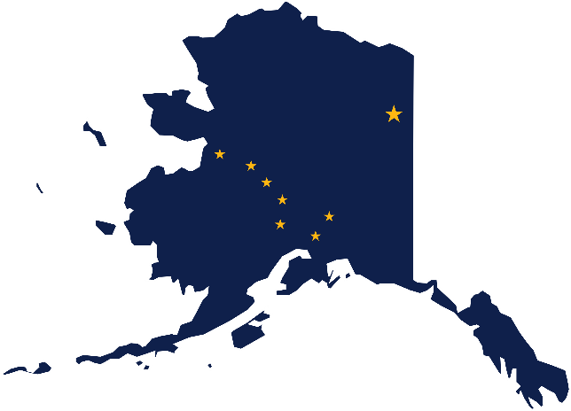
Many of Alaska’s unique protective factors paired with the widespread acceptance of COVID-19 recommendations, like social distancing, wearing masks, and frequent hand washing, have kept our number of COVID-19 cases low. However, Alaska also has many unique factors that put us at risk for future outbreaks. The state may be reopening, but COVID-19 continues to be a threat, so it is important for Alaskan’s to continue working together to protect each other.

For more resources, please visit: http://www.atcemak.com/covid-19-resource-menu-for-communities/ or contact the ANTHC Environmental Health Program at (907) 729-4043 or ceh@anthc.org.

