Why should you wear a cloth facemask?
COVID-19 mostly spreads from person to person when sick people cough, sneeze, talk or breathe near others. When we breathe, we release tiny droplets that float through the air and can carry the virus to other people. When these droplets land on or are breathed in by healthy people, they can become sick. Since many people that have COVID-19 do not feel sick, it’s important to continue social distancing and wear facemasks whenever we go out. These precautions are most effective in communities where everyone actively participates in them.
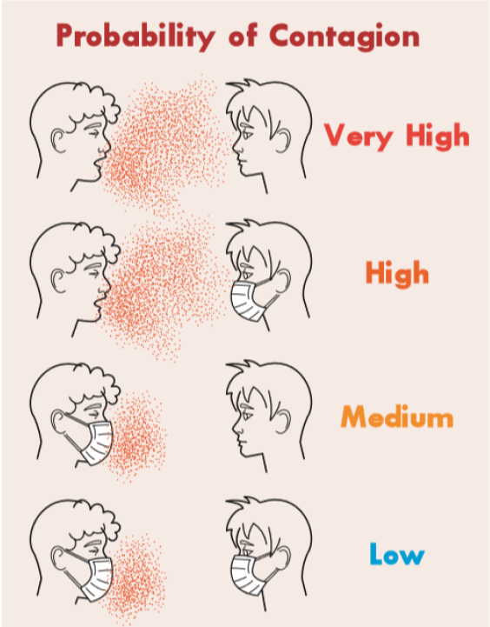
When going out in public place where others are present, it’s recommended we wear cloth facemasks. Cloth facemasks may provide some protection to the wearer, but they mostly help protect others if the wearer is sick. This is important since many people who are sick with COVID-19 do not know it but can still spread it to others.
Cloth Facemask Do’s and Don’ts:
- Make sure you can breathe while wearing it.
- Make sure it covers your mouth and nose.
- Wear it whenever you are in public.
- Wash it regularly and try to always have a clean mask available.
- Only touch the straps when removing it and wash your hands afterwards.
- Don’t wear a mask if you have trouble breathing, are under 2 years old, or are unable to remove it without help.
- Don’t use masks or other supplies intended for healthcare workers.
- Don’t think wearing a facemask replaces social distancing.
- You do not need to wear a facemask outside unless you are within 6 feet of other people.

How to clean cloth facemasks:
- Wash and dry on high heat.
- Wash with soap and warm water and hang dry away from anything else.
- Hang dry or place in a paper bag away from anything else for 3 days. (Virus will become inactive)
- Bake in an oven at 170°F for 30 minutes.

Cloth facemasks can be made with common household materials and can be sewn together or even made without a sewing machine.
Wearing a cloth facemask can help protect your health and the health of your whole community. For more information, please contact the ANTHC Field Environmental Health Program at (907) 729-4043 or ceh@anthc.org.

