How to Build an Emergency Kit
Emergency kits will vary depending on what emergency events are being planned for and the types of supplies that are needed. When building a kit, think about the number of people and pets, season and climate, and local hazards or past emergencies. Your home emergency kit might include:

- Water
- Shelf-stable food for two weeks if sheltering in place.
- Local maps
- First aid kit
- Sleeping bag or blanket for each person
- Batteries
- Can opener
- Duct tape and zip ties
- Whistle
- Work gloves
- Waterproof tarps
- Dust masks
- Flashlights
- Garbage bags
- VHF radio with power supply
- Important family documents stored in a waterproof container.
- Tools
- Toilet Paper
- Cash
- Matches

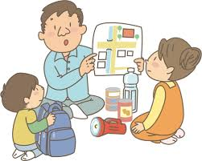
Survivors of past emergencies often suggest also having sturdy footwear, a full change of clothes, prescription medications and glasses, and pet food.
Familiarize yourself with any tools or equipment you keep in your kit. Make sure to maintain your kit by replacing expired items and rethinking your needs as your family changes. You should also have a plan and review it with with your family ahead of time.
Keep your loved ones safe by planning in advance. For more advice and information, please visit: https://www.ready.gov/kit or contact ANTHC Field Environmental Health Program (907) 729-4043 or ceh@anthc.org.

